
SEAFORD COMMUNITY PARTNERSHIP
A Company Limited By Guarantee

The Town Clerk 31/07/2026
Seaford Town Council
Hurdis House
Braod Street
Seaford BN25 1ND

Dear Mr Fisher,

I should be grateful if you would place before the Town Council the following proposal for an Orbital Greenway for pedestrians and cyclists around Seaford. The suggestion came from discussions within the Transport sub-group of the Partnership and included questionnaires of residents attending the Fun Day who were unanimously in favour.

I attach a plan and comments on the proposal and will put a copy in an e-mail in case you wish to print copies in colour for councillors.

The Partnership would be grateful if Seaford Town Council would support the vision to create an orbital pathway which is mostly traffic free or a traffic calmed route with the aim that it is suitable for inexperienced cyclist, young and old. We would further ask that the Town Council requests relevant agencies, particularly Lewes District Council and East Sussex County Council, to begin to work in a “joined up” manner to create a comprehensive infrastructure of safe walking and cycling routes. Such routes will help to encourage a modal shift by providing an alternative to the car leading to an increase in utility and leisure journeys by sustainable transport.

The Council will note that a significant gap in the circuit coincides with the proposed developments to the north of Cradle Hill and present an ideal opportunity (should it be approved) to obtain an s106 contribution to this project.

I trust that the attached specification and comments are self explanatory but if there are any queries please do not hesitate to contact me.

Yours sincerely

Tony Rowswell
Secretary

Seaford Community Partnership

Proposal for an Orbital Greenway for pedestrians and cyclist around Seaford

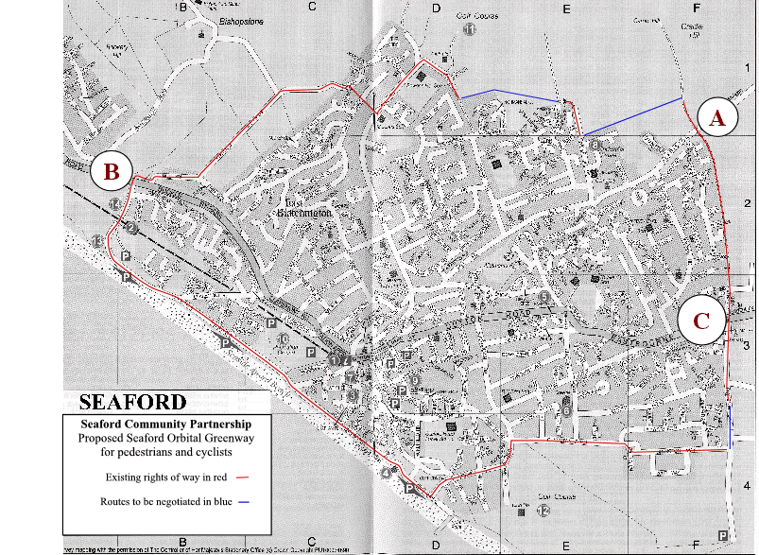

Comments

Point A – Crossing of Alfriston Road
It is proposed that the 30 mph limit be moved to the north east of the crossing point, with appropriate warning signs, to improve safety on that crossing.

Point B – Crossing the A259 at Bishopstone
It is proposed that a 40 mph limit be imposed from Stud Farm to improve safety for the crossing from the lay-by to the east end of the Ouse Valley Nature Reserve, the cycle way being used along the verge from there to Marine Drive and the proposed crossing of the A259. The recent RTAs on the Buckle By-pass and the proposed housing development at Abbots Lodge add emphasis to this proposal. A pedestrian crossing at that junction would further enhance safety.

Point C – Crossing the A259 at Chyngton Lane

It may be necessary to move the 30 mph limit eastwards to the end of the housing and to provide a pedestrian crossing at an appropriate point.

